GP Out Of Hours (OOH)

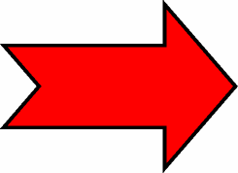
Royal Gwent
Hospital

If you require any further information regarding the YYF Local Emergency Centre (LEC) please ask a member of staff
Service
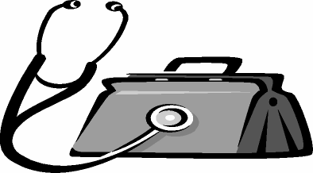
The Out Of Hours Service can assess and treat the following patients:-
- Patients who have an appointment arranged via the OOH GP telephone triage system
Tel No 0845 600 1231
- Patients redirected from the Minor Injury Unit with an illness/condition that requires an urgent assessment.
According to the assessment performed by MIU triage nurse it may be decided that you are able to attend your GP surgery the following day and do not require an urgent OOH GP appointment.
Services / Specialities

Ysbyty Ystrad
Fawr
(YYF)
Local Emergency
Centre
(LEC)
not in YYF
It may be that you have a injury or condition that requires treatment by a speciality that is not available in YYF. Such specialities include -
- Ear Nose and Throat
- Gynaecology
- Maxillo-facial
- Ophthalmology
- Surgery
- Urology
- Orthopaedics
- Paediatrics
If you need to be seen by any of these specialities then you will be transferred / redirected to the Royal Gwent Hospital.
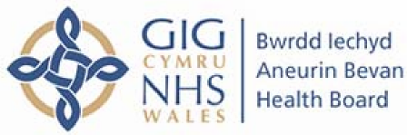
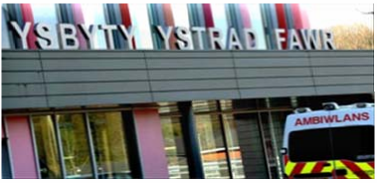
What is an Emergency Nurse
Practitioner (ENP)?
An ENP is a qualified nurse who has extended training in the assessment and management of minor injuries without the need to refer to a Doctor.
They are able to see patients with the following:-

Minor Injury Unit (MIU)

Sometimes the ENP may be unable to manage your injury because of your presenting symptoms, or how the injury happened eg fall greater than 1m or 5 steps. In this case you will be transferred/redirected to the Emergency
Department.
Emergency Department.
Royal Gwent Hospital
You will be triaged and assessed by
a qualified nurse. Their assessment decides 3 points:-
- The urgency of your condition
- Who is the best person to deal with your condition
- Where is the most appropriate place for your condition to be managed
- Limb injuries
- Wounds and burns
- Insect, animal or human bites
- Eye problems
- Minor head and face injuries (NOT in children under 1 yr)
- Minor ENT problems including foreign bodies
- Minor neck injuries
- Minor back injuries(between age 20-55)
- Minor chest injuries

- T
The triage nurse is there to ensure that you are seen by the right person in the right place. You may require redirection or transfer to one of the following services:
- YYF Medical Assessment Unit
- Out Of Hours GP
- Own GP
- Pharmacist
- Local Accident and Emergency Department
Once the triage nurse has decided that your condition is suitable for MIU, you will wait to see a trained Emergency Nurse Practitioner

An ENP can provide the following:-

- Prescriptions or administer medicines

- Request and interpret x-rays

- Reduce minor dislocations

- Apply casts and splints

- Remove foreign bodies

Medical Assessment Unit
(MAU)
The Medical Assessment (MAU) is staffed with Medical Doctors, Advanced Nurse Practitioners (ANP), Qualified Nurses and Health Care Assistants (HCA’s).

The MAU can assess and treat the following patients –

- Patients referred from the GP

- Patients redirected from the Minor
Injury Unit

- Patients with medical problems
transferred by ambulance.

- Patients who self present with medical problems eg chest pain.

